Focus areas in English: Annotation
The scope and sequence tab for the English curriculum includes a range of documents. These have be designed to assist teachers to view the curriculum in more detail and provide additional information on the focus area of each content description. Please note that the focus area information is not included on the digital version of the curriculum.

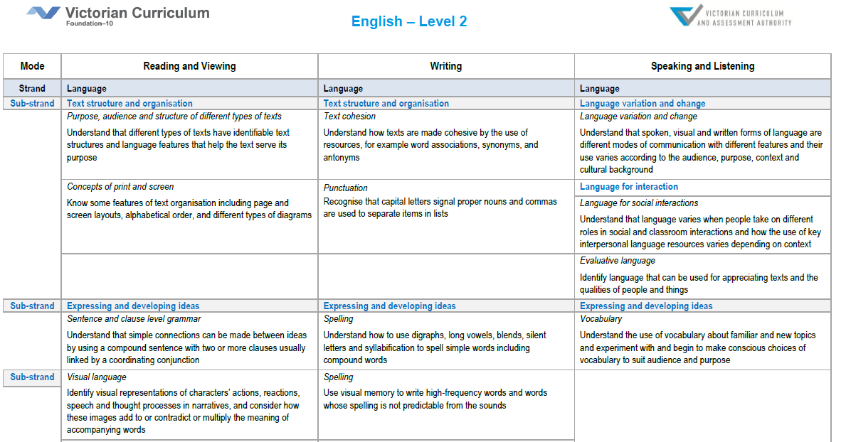
The focus area for each content description is indicated in italics

Focus areas in English
Strand Language  Sub-strand Language variation and change  Focus area Language variation and change - How English varies according to context and purpose, including cultural and historical contexts  Sub-strand Language for interaction  Focus areas Language for social interactions - How language used for different formal and informal social interactions is influenced by the purpose and audience Evaluative language - How language is used to express opinions, and make evaluative judgments about people, places, things and texts  Sub-strand Text structure and organisation  Focus areas Purpose, audience and structures of different types of texts - How texts serve different purposes and how the structures of types of texts vary according to the text purpose Text cohesion - How texts work as cohesive wholes through language features which link the parts of the text together, such as paragraphs, connectives, nouns and associated pronouns Punctuation - How punctuation works to perform different functions in a text. Concepts of print and screen - The different conventions that apply to how text is presented on a page or screen  Sub-strand Expressing and developing ideas  Focus areas Sentences and clause level grammar - What a clause is and how simple, compound and complex sentences are constructed through one clause (simple) or by combining clauses using different types of conjunctions (compound and complex) Word level grammar - The different classes of words used in English (nouns, verbs, etc) and the functions they perform in sentences and when they are combined in particular recognisable groups such as phrases and noun groups Visual language - How images work in texts to communicate meanings, especially in conjunction with other elements such as print and sound  Sub-strand Phonics and word knowledge  Focus areas Phonics and phonemic awareness (sounds of language) - Knowledge of sounds of language and how these are combined in spoken words Phonic knowledge - The relationship between sounds and letters and how these are combined when reading and writing Spelling - Knowledge about how sounds (phonemes) are represented by letters or letter patterns; knowledge of meaning units within words (morphemes) and word origins | Strand Literature  Sub-strand Literature and context  Focus area Literature and context - How texts reflect the context of culture and situation in which they are created  Sub-strand Responding to literature  Focus areas Personal responses to the ideas, characters and viewpoints in texts - An individual response to the ideas, characters and viewpoints in literary texts, including relating texts to their own experiences Expressing preferences and evaluating texts - Expressing a personal preference for different texts and types of texts, and identifying the features of texts that influence personal preference  Sub-strand Examining literature  Focus areas Features of literary texts - The key features of literary texts and how they work to construct a literary work, such as plot, setting, characterisation, mood and theme Language devices in literary texts including figurative language - The language devices that authors use and how these create certain meanings and effects in literary texts, especially devices in poetry  Sub-strand Creating literature  Focus areas Creating literary texts - Creating their own literary texts based on the ideas, features and structures of texts experienced Experimentation and adaptation - Creating a variety of texts, including multimodal texts, adapting ideas and devices from literary texts | Strand Literacy  Sub-strand Texts in context  Focus area Texts and the contexts in which they are used - How texts relate to their contexts and reflect the society and culture in which they are created  Sub-strand Interacting with others  Focus areas Listening and speaking interactions - The purposes, contexts and skills through which students engage in listening and speaking interactions Oral presentations - The formal oral presentations and related skills that students engage in, including presenting recounts and information, and presenting and arguing a point of view  Sub-strand Interpreting, analysing, evaluating  Focus areas Purpose and audience - Recognising and analysing differences between different types of texts Reading processes - Strategies for using and combining contextual, semantic, grammatical and phonic knowledge to decode texts including predicting, monitoring, cross-checking, self-correcting, skimming and scanning Comprehension strategies - Strategies for constructing literal and inferential meaning from texts, including visualising, making connections, paraphrasing and predicting Analysing and evaluating texts - Analysis and evaluation of how text structures and language features construct meaning and influence readers/viewers  Sub-strand Creating texts  Focus areas Creating texts - Creating different types of spoken, written and multimodal texts using knowledge of text structures and language features Editing - Editing texts for meaning, structure and grammatical features Handwriting - Developing legible handwriting skills in English, beginning with unjoined letters and moving to joined letters Use of software - Using a range of software applications to construct and edit print and multimodal texts

